Day 1: Big Bang

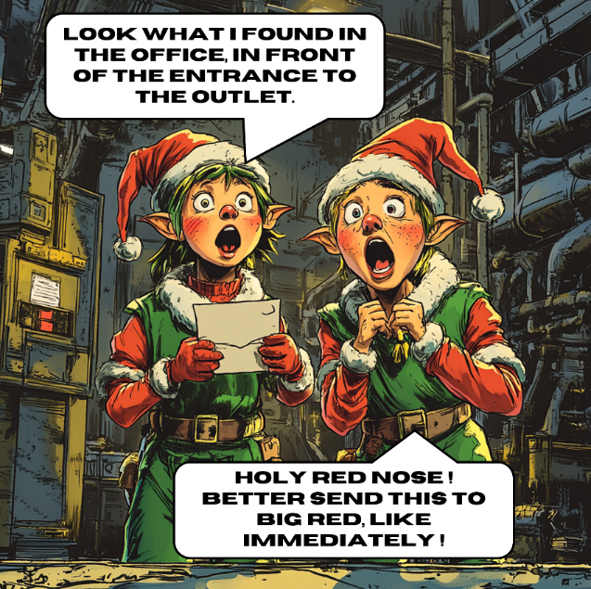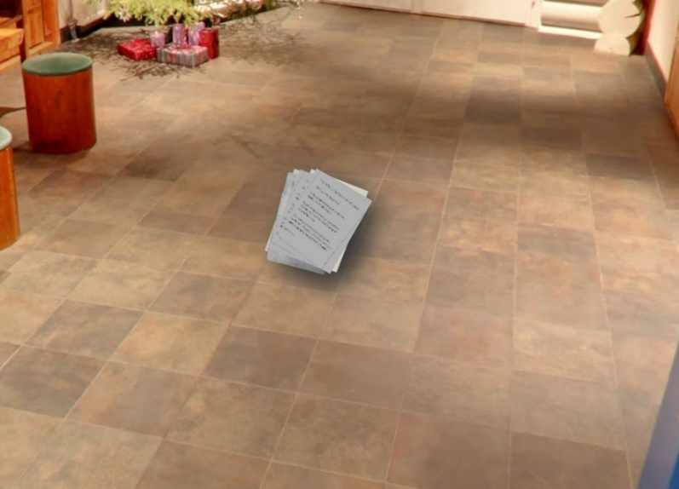

*Q: What is the name of the outlet?*

The evidence contains the above picture. The text on the depicted stack of papers is illegible. The first step is to see if there is any interesting metadata. Looking at the properties of the file, no metadata seems to be available. For a more thorough look, I enter the image in Forensically, however this tool also finds no metadata. Lastly, I run Exiftool on this image and we do get more information now. Specifically, geographic coordinates are given: 66 deg 32' 35.95" N, 25 deg 50' 49.95" E. Entering these in Google maps shows a very relevant location: Lapland. The coordinates point to a place called Iittala & co Napapiiri, which is tagged as an outlet for home goods. Therefore, the answer for this question is:

**Iittala & co Napapiiri**.